**Week 1 – Ventilation and Compression task**

**1 Theory part:**

Definition of child groups:

* 1 month old = neonate/newly born
* **1 to 12 months = infant**
* 1 to 8 years = child
* <= 8 years = adults
* Main subject = **Infant**

Ventilation:

Airway:

* Before beginning with ventilation ensure that the victim has an open airway
* The most common cause of airway obstruction is the tongue.
* Many methods to open an airway: Head Tilt–Chin Lift Maneuver, Jaw-Thrust Maneuver, Foreign-Body Airway Obstruction and special techniques for trained airway providers. The most practicable method in regard to a baby patient simulator is the Head Tilt-Chin Lift Maneuver: „If the victim is unresponsive and trauma is not suspected, open the child’s airway by tilting the head back and lifting the chin (Figure 4). Place one hand on the child’s forehead and gently tilt the head back. At the same time place the fingertips of your other hand on the bony part of the child’s lower jaw, near the point of the chin, and lift the chin to open the airway“

Breathing:

* First check if the vitcim is able to breathe by holding his airway open and look for breathing signs.
* If no breathing signs can be detected you have to prepare the victim for rescue breathing. Thereby you have to maintain an open airway by using for instance Head Tilt–Chin Lift Maneuver, Jaw-Thrust Maneuver etc. 🡪 Mouth-to-Mouth-and-Nose and Mouth-to-Mouth Breathing
* Ventilation with barrier-devices: „Two broad categories of barrier devices are available: masks and face shields. Most masks have a 1-way valve, which prevents the victim’s exhaled air from entering the rescuer’s mouth. When barrier devices are used in resuscitation of infants and children, they are used in the same manner as in resuscitation of adults“

Oxygen:

* The combination of low blood flow and low oxygenation contributes to metabolic acidosis and organ failure.
* Oxygen should be administered to children with demonstrated cardiopulmonary arrest or compromise, even if measured arterial oxygen tension is high. Whenever possible, administered oxygen should be humidified to prevent drying and thickening of pulmonary secretions; dried secretions may contribute to obstruction of natural or artificial airways.

Compression:

* Definition of chest compression: „Chest compressions are serial, rhythmic compressions of the chest that cause blood to flow to the vital organs (heart, lungs, and brain) in an attempt to keep them viable until ALS can be provided. Chest compressions provide circulation as a result of changes in intrathoracic pressure and/or direct compression of the heart.218219220221222 Chest compressions for infants and children should be provided with ventilations.“
* Indicators for ches compression: „Lay rescuers should provide chest compressions if the infant or child shows no signs of circulation (normal breathing, coughing, or movement) after delivery of rescue breaths. Healthcare providers should provide chest compressions if the infant or child shows no signs of circulation (breathing, coughing, movement, or pulse) or if the heart rate/pulse is <60 bpm with signs of poor perfusion after delivery of rescue breaths. Profound bradycardia in the presence of poor perfusion is an indication for chest compressions because cardiac output in infancy and childhood is largely dependent on heart rate, and an inadequate heart rate with poor perfusion indicates that cardiac arrest is imminent. No scientific data has identified an absolute heart rate at which chest compressions should be initiated; the recommendation to provide cardiac compression for a heart rate <60 bpm with signs of poor perfusion is based on ease of teaching and skills retention“
* Chest compression for infants 🡪 Two finger technique, Two thumb–encircling hands technique (this is the preferred 2-rescuer technique for healthcare providers when physically feasible
* External chest compressions for infants and children should always be accompanied by rescue breathing. In the infant and child, a compression-ventilation ratio of 5:1 is maintained for both 1 and 2 rescuers. The 2-rescuer technique should be taught to healthcare providers. For infants in the special resuscitation circumstances of the delivery room and neonatal intensive care setting, even more emphasis is placed on ventilation during resuscitation, and a 3:1 compression-ventilation ratio is recommended (see “Part 11: Neonatal Resuscitation”).

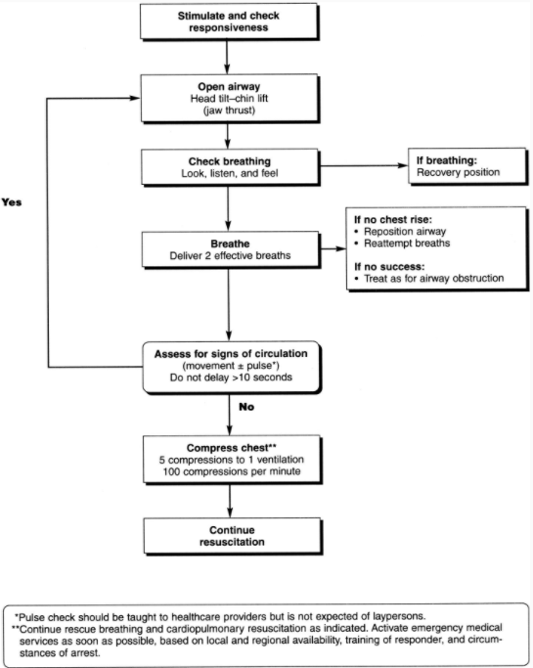

Ein Bild, das Text, Strichzeichnung enthält.

Ein Bild, das Text, Strichzeichnung enthält.

**2 Technical part**

**Feedback:**

Main question:

How can we get appropriate feedback when applying ventilation and compression tasks with our baby patient simulator?

Necessary needs:

* How can we measure the optimal compression depth?
* How can we measure the optimal tension for a proper compression?
* How can we guarantee proper ventilation?

Implementation ideas:

* Sensors?
* Audio-Feedback?
* Led Feedback?
* Monitoring?

Possible approaches:

* Smart-ring based ccd feedback (compression)
* Approach with two accelerometers (compression)
* IMU-Sensors (ventilation)

Two paper in regard to sensors in the compression context:

[1] S. Lee *et al.*, ‘Development of Smart-Ring-Based Chest Compression Depth Feedback Device for High Quality Chest Compressions: A Proof-of-Concept Study’, *Biosensors*, vol. 11, no. 2, Art. no. 2, Feb. 2021, doi: 10.3390/bios11020035.

[2] Y. Noh, A. Shimomura, M. Segawa, H. Ishii, A. Takanishi, and K. Hatake, ‘Development of Tension/Compression Detection Sensor System designed to acquire quantitative force information while training the airway management task’, Aug. 2009, pp. 1264–1269. doi: 10.1109/AIM.2009.5229798.

**Integration:**

Main question:

How can we integrate our results from the feedback section in our baby patient simulator properly?

* First to do: Analyse the given prototype

Source for theory section:

[3] ‘Part 9: Pediatric Basic Life Support’, *Circulation*, vol. 102, no. suppl_1, p. I–253, Aug. 2000, doi: 10.1161/circ.102.suppl_1.I-253.